SAY NO TO APPEARANCE ANXIETY

Prepared for beauty and clothing industries
psychological counseling industries

Prepared by
1132-FD56-Ellen
Statistics

April 11, 2025
TABLE OF CONTENTS
EXECUTIVE SUMMARY . . . . . . . . . . . . . . . . . . . . . . . . . . . . . . . . . . . . . . . . . . . iii

PROBLEM . . . . . . . . . . . . . . . . . . . . . . . . . . . . . . . . . . . . . . . . . . . . . . . . . . . . . . . . 1

MOTHODOLOGY APPLIED . . . . . . . . . . . . . . . . . . . . . . . . . . . . . . . . . . . . . . . . . 1

BACKGROUND . . . . . . . . . . . . . . . . . . . . . . . . . . . . . . . . . . . . . . . . . . . . . . . . . . . . 1

DISCUSSION OF FINDINGS . . . . . . . . . . . . . . . . . . . . . . . . . . . . . . . . . . . . . . . . . 2

- Anxiety Occurrence . . . . . . . . . . . . . . . . . . . . . . . . . . . . . . . . . . . . . . . . . . . 2
a1. The main causes of anxiety . . . . . . . . . . . . . . . . . . . . . . . . . . . . . . . . . . 3
a2.Corresponding behaviors . . . . . . . . . . . . . . . . . . . . . . . . . . . . . . . . . . . . 3
- Antianxiety Behaviors . . . . . . . . . . . . . . . . . . . . . . . . . . . . . . . . . . . . . . . . . 4 b1.Changes in appearance . . . . . . . . . . . . . . . . . . . . . . . . . . . . . . . . . . . . . . 4 b2.Psychological adjustments . . . . . . . . . . . . . . . . . . . . . . . . . . . . . . . . . . . 5 b3. Projections . . . . . . . . . . . . . . . . . . . . . . . . . . . . . . . . . . . . . . . . . . . . . . . 6
CONCLUSIONS AND RECOMMENDATIONS . . . . . . . . . . . . . . . . . . . . . . . . . . 6

REFERENCE . . . . . . . . . . . . . . . . . . . . . . . . . . . . . . . . . . . . . . . . . . . . . . . . . . . . . 6

APPENDIX . . . . . . . . . . . . . . . . . . . . . . . . . . . . . . . . . . . . . . . . . . . . . . . . . . . . . . . 7

LIST OF FIGUERS
Figure

- THE DEGREE OF IMPORTANCE ATTACHED TO ONE’S
APPEARANCE . . . . . . . . . . . . . . . . . . . . . . . . . . . . . . . . . . . . . . . . . . . . . . 3
- CORRESPONDING BEHAVIORS DUE TO APPEARANCE
ANXIETY . . . . . . . . . . . . . . . . . . . . . . . . . . . . . . . . . . . . . . . . . . . . . . . . . . . . 4
- WAYS PEOPLE TRY TO HAVE BETTER APPEARANCES . . . . . . . . . . . . 5
- THE MOST EFFECTIVE WAY FOR PEOPLE TO RESIST ANXIETY . . . . 6

EXECUTIVE SUMMARY
This study was designed to analyze the causes and impact of appearance anxiety to people in this modern day and age. As a college student, I am surrounded by people of my age who care about and feel anxious about their appearances. This phenomenon tell me that the effects of appearance anxiety are far-reaching and may be expanding. It has indeed become one of the worries of modern people.
Appearance anxiety is a form of social appraisal anxiety that is prevalent in the influencer culture. It specifically refers to an individual's preoccupation with his or her appearance and the potential for negative social evaluations based on it, leading to persistent negative emotions such as worry, distress, fear, and dissatisfaction.
There are three major factors in the development of appearance anxiety, which are the aesthetic standards shaped by the media, personal growth experience and psychological factors. Moreover, most people exhibit the behavior of comparing themselves to others when they have appearance anxiety. Excessive focus on physical appearance and physical characteristics, avoidance of social occasions and overreliance on plastic surgery or cosmetics are also corresponding behaviors that can occur.
When anxiety arises, people need to have some ways to combat it. I have categorized these methods into two types, which are changes in appearance and psychological adjustments. In terms of changing in appearance, most people apply ways of wearing nice clothes and accessories and making up. However, losing weight and staying in good shape and maintaining one’s face more diligently are little less to apply, which implies rapid external changes can bring greater security to people's appearance and are therefore seen as a more effective way to change their appearance. In terms of psychological adjustments, developing intrinsic value and improve themselves is the most powerful thing to build self-confidence and considered the most effective way to help with appearance anxiety rather than practicing self-affirmation, avoiding comparison both take the second place and learning stress reduction and relaxation techniques. I believe that self-confidence helps people believe that they have a higher value, and are less likely to become anxious because of other people's negative comments about their appearances.
On the basis of these findings, I recommend the relevant industries can create suitable products or services according to the different needs of customers, helping them to be free from appearance anxiety.

PROBLEM

This study was designed to analyze the causes and impact of appearance anxiety to people in this modern day and age. Specifically, the study seeks the answers to the following questions:

- How important do people think appearance is to them? What is the main reason of their appearance anxiety?

- What happens when people feel anxious about their appearances? What have they tried to make themselves look good?

- What can help people the most when they have appearance anxiety?

MOTHODOLOGY APPLIED

- Questionnaire: Google form

- Time period: 2 weeks ( March 17~ March 31)

- Number of responses: 51

BACKGROUND
As a college student, I am surrounded by people of my age who care about their appearances. I have observed that some of my friends are prone to belittle themselves because of the beauty of others, some are very concerned about their appearances all the time, and some refuse to socialize because they think their appearances are not desirable. These phenomena tell me that the effects of appearance anxiety are far-reaching and may be expanding. It has indeed become one of the worries of modern people.
A study from the BMC shows that appearance anxiety is a form of social appraisal anxiety that is prevalent in the influencer culture. It specifically refers to an individual's preoccupation with his or her appearance and the potential for negative social evaluations based on it, leading to persistent negative emotions such as worry, distress, fear, and dissatisfaction.
So, what causes appearance anxiety? Scholars believe that engaging in more appearance- or body-related activities increases the likelihood of appearance-related psychological problems. Also, the search for social acceptance in building online relationships is an important factor in causing appearance anxiety. Further, following, editing, and sharing selfies may lead to more negative body image and increased body dissatisfaction. Finally, negative social comparisons may lead to unpleasant experiences.

However, a study from UpToGo offers us some ways to combat appearance anxiety. For example, practicing self-acceptance and affirmation, avoiding comparisons with others, limiting reliance on mirrors, developing intrinsic values and competencies, maintaining a healthy lifestyle, and learning stress reduction and relaxation techniques are all good ways to help fight appearance anxiety.
Even though many people suffer from appearance anxiety, it is not insurmountable. I hope that through this study, people can have a better understanding of why they are plagued by appearance anxiety. I also hope to provide information to the beauty and psychological counseling market so that manufacturers can maximize the help they can provide to their clients.

DISCUSSION OF FINDINGS
The results of this research provide an overview of why people are not satisfied with their appearances and how they react when they suffer from appearance anxiety. Finally, this research aims to find the solutions of people’s appearance anxiety. The research findings presented here fall into two categories: (a) Anxiety Occurrence and (b) Antianxiety Behaviors.
a. Anxiety Occurrence
First of all, I would like to explore how much importance people attach to their appearance. I have categorized the degree of importance attached to one's appearance into a scale of one to five. (One being the lowest and five being the highest.) In this list of 51 responses, 24 people responded on a scale of four, which means most people attach a certain degree of importance to their physical appearance.

Figure 1

THE DEGREE OF IMPORTANCE ATTACHED TO ONE’S APPEARANCE
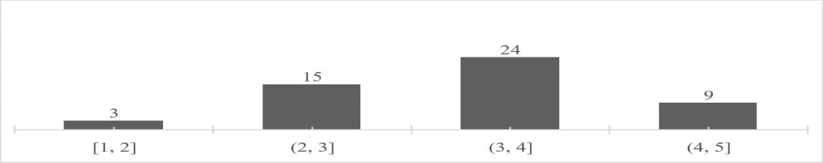

a1. The main causes of anxiety
Based on my research, most people often suffer from appearance anxiety. And according to UpToGo's research, people often suffer from appearance anxiety for the following reasons.
- The aesthetic standards shaped by the media: Social software and other media often present idealized standards of appearance that often deviate from reality, causing people to not only question their appearance, but also affect their emotional state.

- Personal growth experience: If an individual has been ridiculed, bullied, or treated unfairly because of his or her appearance, he or she may have longterm anxiety about his or her own image, and may even become appearance-anxious.

- Psychological factors: If an individual's self-worth is overly dependent on appearance due to low self-esteem, any negative comments about appearance will easily affect his or her psychological state. In addition, people with anxiety traits or perfectionist tendencies are prone to have extreme standards about their appearance.
All three of these reasons are major factors in the development of appearance anxiety.
a2. Corresponding behaviors
UpToGo's research suggests a number of symptoms of appearance anxiety, some of which are similar to behaviors I've observed in my close friends as a result of appearance anxiety.
- Excessive focus on physical appearance and physical characteristics.

- Comparison with others.

- Avoidance of social occasions.

- Over-reliance on plastic surgery or cosmetics.

Based on my research, most people exhibit the behavior of comparing themselves to others. Next, excessive focus on physical appearance and physical characteristics, avoidance of social occasions and over-reliance on plastic surgery or cosmetics, respectively.
Figure 2
CORRESPONDING BEHAVIORS DUE TO APPEARANCE ANXIETY
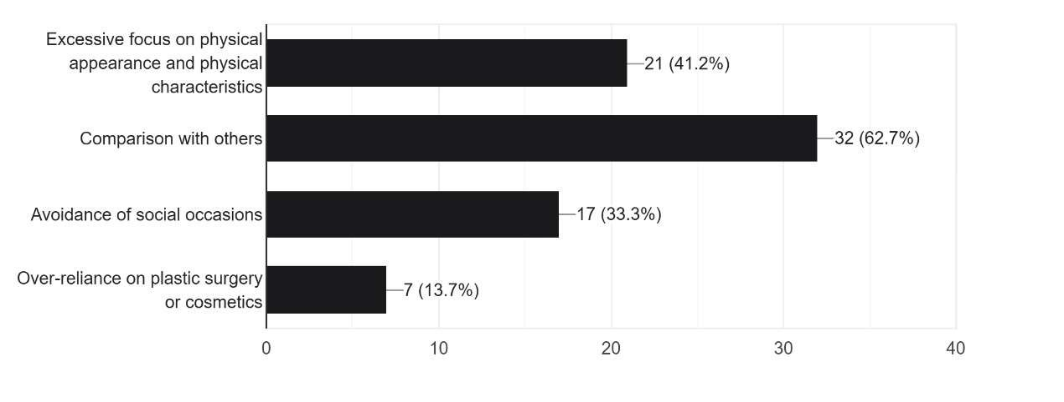
b.Antianxiety Behaviors
Next, when anxiety arises, people need to have some ways to combat it. I have categorized these methods into two types, which are changes in appearance and psychological adjustments.
b1. Changes in appearance
Here are some ways that I've observed in my close friends or I consider it works to change their appearance, which can provide information for beauty and clothing industries to produce effective products for consumers.
- Making up.

- Wearing nice clothes and accessories.

- Losing weight and staying in good shape.

- Having plastic surgery.

- Maintaining one’s face more diligently.

According to Figure 3, besides having plastic surgery, other methods have been tried. Among them, wearing nice clothes and accessories is the most tried. Next, making up, losing weight and staying in good shape and maintaining one’s face more diligently, respectively.

Figure 3
WAYS PEOPLE TRY TO HAVE BETTER APPEARANCES
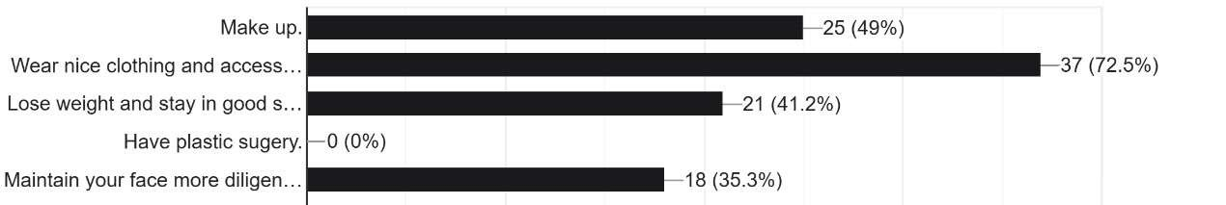

b2. Psychological adjustments
Since appearance anxiety has been recognized as a disorder and the symptoms associated with it have appeared. Therefore, counseling for anxiety is inevitably necessary. Below is a list of ways to help with appearance anxiety that I have compiled based on research from UpToGo and the Child Welfare League.
- Practicing self-affirmation.
- Avoiding comparison with others.
- Developing intrinsic value and improve yourself.
- Learn stress reduction and relaxation techniques.

Figure 4
THE MOST EFFECTIVE WAY FOR PEOPLE TO RESIST ANXIETY
. 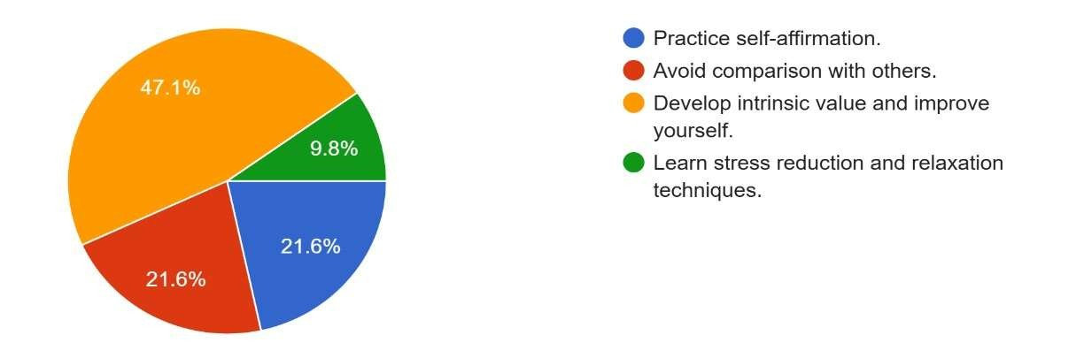
According to Figure 4, developing intrinsic value and improve themselves is considered the most effective way to help with appearance anxiety. Next, practicing self-affirmation and avoiding comparison both take the second place. Least, learning stress reduction and relaxation techniques takes the third place.
b3. Projections
In terms of changing the appearance, I presume that plastic surgery is not regarded as an effective way to change the appearance because of the economic situation and the age group. However, most people consider wearing nice clothes and accessories and making up as better way than losing weight and staying in good shape and maintaining one’s face more diligently, which implies rapid external changes can bring greater security to people's appearance and are therefore seen as a more effective way to change their appearance.
In terms of psychological adjustments, I presume that developing intrinsic value and improve oneself is the most powerful thing people can do for their self-confidence.
With self-confidence, people are sure that they have a higher value, and they are less likely to become anxious because of other people's negative comments about their appearance.

CONCLUSIONS AND RECOMMENDATIONS
Analysis of anxiety occurrence and anxiolytic behaviors leads to the following conclusions and recommendations about the appearance anxiety.

- The aesthetic standards shaped by the media, personal growth experience and psychological factors are three main causes of appearance anxiety.

- Most people exhibit the behavior of comparing themselves to others when they suffer from appearance anxiety.

- To change appearance, making up and wearing nice clothes and accessories are ways that most be tried because of they can bring rapid external changes.

- Developing intrinsic value and improve oneself is the most powerfully psychological adjustment people can do for their self-confidence.
On the basis of these findings, I recommend the relevant industries can create suitable products or services according to the different needs of customers, helping them to be free from appearance anxiety.

REFERENCE

- https://uptogo.com.tw/%E5%81%A5%E5%BA%B7/%E8%BA%AB %E5%BF%83%E7%A7%91/%E5%AE%B9%E8%B2%8C%E7%84
%A6%E6%85%AE%E6%98%AF%E4%BB%80%E9%BA%BC/

- https://www.children.org.tw/news/news_detail/3145

- https://job365.24hosting.com.tw/psychological.php?id=15

- https://bmcpsychology.biomedcentral.com/articles/10.1186/s4035902
3-01495-7

APPENDIX

- https://docs.google.com/forms/d/1qJBdMh-
UH1KdRr7kFRy2qcIVrW1AK_e69oJcUAPsBCg/edit#responses
- The questionnaire consists of the following 10 questions:

- What is your gender?
- How old are you?
- How important do you think appearance is to you?

- How often do you suffer from appearance anxiety?

- What is the main reason of your appearance anxiety?

- What happens when you feel anxious about your appearance?

- What have you tried to make yourself look good?

- How much does your appearance affect your ability to work and study?

- What can help you the most when you have appearance anxiety?

- What do you think appearance anxiety means to you?

